Common Core &
Essential Standards Training
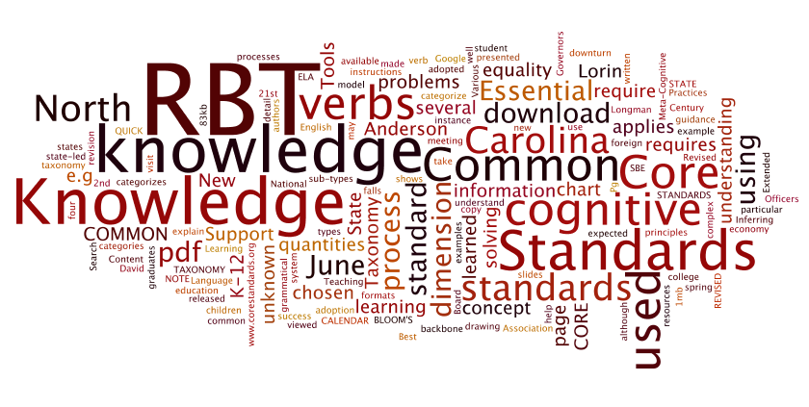

Columbus County Schools
2011-2012

Teacher: ________________________

